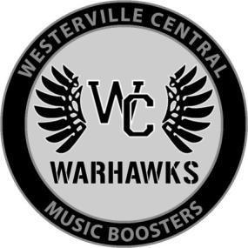
Westerville Central Music Boosters

2026-2027 Sponsorships
P.O. Box 2273, Westerville, OH 43086 warhawkmb@gmail.com

Thank you for supporting the music programs at Westerville Central High School
Enclosed, please find our donation of $
Sponsor Name to be Displayed: Contact Name/Title: Email: Phone: Address: City/St/Zip:
Select Level | Type | Amount | Benefits
 | Director | $1000 | Trailer logo, concession stand signage, name/logo placement on WCMB website (with link to company website), included in 5 boosters Facebook posts, announcement recognition at 5 home football games, listing in all music programs for WCHS (band,  orchestra, choir) concerts.
 | Field Commander | $750 | Concession stand signage, name/logo placement on WCMB website (with link to company website), included in 4 boosters Facebook posts, announcement recognition at 4 home football  games, listing in 4 music programs for WCHS concerts.
 | Captain | $500 | Concession stand signage, name/logo placement on WCMB website, included in 3 boosters Facebook posts, announcement recognition at 3 home football games, listing in 3 music programs for WCHS concerts.
 | Soloist | $250 | Name/logo placement on WCMB website, included in 2 boosters  Facebook posts, announcement recognition at 2 home football games, listing in 2 music programs for WCHS concerts.
 | Ensemble | $125 | Name/logo placement on WCMB website, included in 1 boosters Facebook post, announcement recognition at 1 home football  game, listing in 1 music program for WCHS concert.
 | Member | In-Kind Donation | Donations of supplies, merchandise, and gift cards are always welcome from individuals and local businesses.

**Please email print ready logo to warhawkmb@gmail.com

We are a 501(c)3 charitable organization. Tax ID #58-2677727
Please make checks payable to Westerville Central Music Boosters and mail to: WCMB, PO Box 2273, Westerville, OH 43086
You may pay by credit card here: https://westerville-central-music-boosters.square.site/shop/sponsorships/6

